BIG BANG BAR STUFF
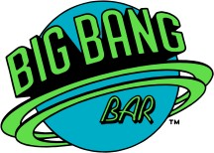
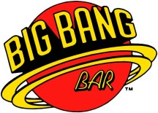
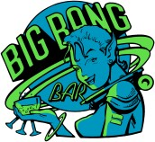
Blue Planet Logo Red Planet Logo Planet Girl
Embroidery & screen-printing Embroidery only Embroidery only
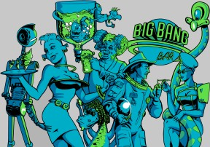
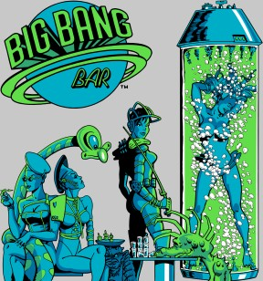
Astronaut Tube Dancer
You can have one of these two images screen-printed on any shirt you select for $6. The gray is a background color only and will instead be the color of the shirt you order.

PRODUCTS

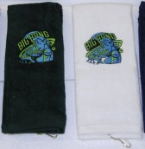
TOWEL/BP – Towel with embroidered Blue Planet Logo
TOWEL/RP – Towel with embroidered Red Planet Logo
TOWEL/PG – Towel with embroidered Planet Girl

Bar Towel $15
100% cotton terry velour, 16” x 26”, tri-fold with a hook for easy display. Your selected logo will be embroidered on the bottom 1/3 of the towel.
Available in black, dark green, navy, khaki, white

DYED/BP – Blue Planet Logo with “Looped in Space”
DYED/RP – Red Planet Logo with “Open 476 Days a Year”
DYED/PG – Planet Girl with “Don’t Drink and Fly”

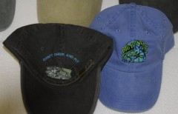
Pigment Dyed Cap $18
Washed-look 100 % cotton with fabric closure and brass buckle. Embroidered art on front, text on back arch. Left hat is folded and upside down to show text.
Available in:
black, pine green, navy, royal blue, khaki

TWIL/BP – Blue Planet Logo with “Looped in Space”
TWIL/RP – Red Planet Logo with “Open 476 Days a Year”
TWIL/PG – Planet Girl with “Don’t Drink and Fly”

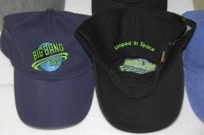
Solid Twill Cap $18
Solid colored 100% cotton with fabric closure and brass buckle. Embroidered art on front, text on back arch. Right hat is folded and upside down to show text.
Available in:
black, navy, light blue, khaki, white

MESH/BP – Embroidered Blue Planet Logo
MESH/RP – Embroidered Red Planet Logo
MESH/PG – Embroidered Planet Girl

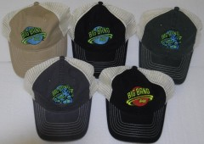
Mesh-backed Trucker Cap $16
Stone color soft mesh on back and sides, 100% cotton, plastic tab closure.
Embroidered art on front. No text on back
Available in black, dark green, navy, khaki, gray

EPS/BP – Polo Shirt with Embroidered Blue Planet Logo on front
EPS/RP – Polo Shirt with Embroidered Red Planet Logo on front
EPS/PG – Polo Shirt with Embroidered Planet Girl on front

Embroidered Polo Shirt $23
A soft 5 ounce 65/35 poly/cotton pique, double needle stitching, metal buttons.
Available in black, dark green, navy, gray, white
Sizes: XS – XL; Additional sizes, 2XL - 6XL
2XL add $3, 3XL add $5, 4XL add $7, 5XL add $9, 6XL add $11
Add $6 to have art screen-printed on the back, specify Astronaut or Tube Dancer

EPP/BP – Pocket Polo with Embroidered Blue Planet Logo on front
EPP/RP – Pocket Polo with Embroidered Red Planet Logo on front
EPP/PG – Pocket Polo with Embroidered Planet Girl on front

Embroidered Pocket Polo $25
A soft 5 ounce 65/35 poly/cotton pique, double needle stitching, metal buttons.
Available in black, navy, dark green, gray, white
Sizes: XS – XL;
Additional sizes, 2XL - 6XL,
2XL add $3, 3XL add $5, 4XL add $7, 5XL add $9, 6XL add $11
Add $6 to have art screen-printed on the back, specify Astronaut or Tube Dancer

JPS - Jersey Knit Polo Shirt with screen-printed Blue Planet Logo on front chest

Jersey Polo Shirt $16
Blue Planet Logo screen-printed on the front of a 50/50 poly/cotton jersey knit short sleeve sport shirt with wood tone buttons and double stitched bottom hem.
Available in black, dark green, purple, navy, royal blue, light blue, gray, white
Sizes: XS – XL;
Additional sizes, 2XL - 5XL
4XL and 5XL not available in dark green, purple, or light blue
2XL add $3, 3XL add $5, 4XL add $7, 5XL add $9
Add $6 to have art screen-printed on the back, specify Astronaut or Tube Dancer

JPP - Jersey Knit Pocket Polo with screen-printed Blue Planet Logo on front

Jersey Pocket Polo $17
Blue Planet Logo screen-printed on the front of a 50/50 poly/cotton jersey knit short sleeve sport shirt with a pocket. Wood-tone buttons and double stitched bottom hem.
Available in black, dark green, navy, royal blue, gray, white
Sizes: XS – XL;
Additional sizes, 2XL - 3XL; 3XL not available in dark green or royal blue
2XL add $3, 3XL add $5
Add $6 to have art screen-printed on the back, specify Astronaut or Tube Dancer

SST - Short Sleeve Tee Shirt with screen-printed Blue Planet Logo on front chest

Short Sleeve Tee Shirt $12
Blue Planet Logo screen-printed on the front of a short sleeve 6.1 oz. 100% cotton tee.
Available in black, dark green, purple, navy, royal blue, light blue, gray, white
Sizes: XS – XL;
Additional sizes, 2XL - 5XL; 4XL - 5XL not available in purple or light blue
2XL add $2, 3XL add $3, 4XL add $4, 5XL add $5
Add $6 to have art screen-printed on the back, specify Astronaut or Tube Dancer

SSPT - Short sleeve pocket tee with screen-printed Blue Planet Logo on front

Short Sleeve Pocket Tee Shirt $13
Blue Planet Logo screen-printed on the front of a pocketed short sleeve 6.1 oz. 100% cotton tee.
Available in black, dark green, navy, royal blue, gray, white
Sizes: XS - XL
Additional sizes, 2XL - 5XL; 4XL - 5XL not available in dark green or royal blue
2XL add $2, 3XL add $3, 4XL add $4, 5XL add $5
Add $6 to have art screen-printed on the back, specify Astronaut or Tube Dancer

LST - Long sleeve tee with screen-printed Blue Planet Logo on front chest

Long Sleeve Tee Shirt $14
Blue Planet Logo screen-printed on the front of a long sleeve 6.1 oz. 100% cotton tee.
Available in black, dark green, purple, navy, royal blue, gray, white
Sizes: XS - XL
Additional sizes, 2XL - 5XL;
4XL - 5XL not available in dark green, purple or royal blue
2XL add $2, 3XL add $3, 4XL add $4, 5XL add $5
Add $6 to have art screen-printed on the back, specify Astronaut or Tube Dancer

CREW - Crewneck sweatshirt with screen-printed Blue Planet Logo on front chest

Crewneck Sweatshirt $18
Blue Planet Logo screen-printed on the front of a 50/50 poly/cotton 9.0 oz. sweatshirt.
Available in black, dark green, purple, navy, royal blue, light blue, gray, white
Sizes: XS - XL
Additional sizes, 2XL - 4XL; 4XL only available in black, navy, and gray
2XL add $3, 3XL add $5, 4XL add $7
Add $6 to have art screen-printed on the back, specify Astronaut or Tube Dancer

HOOD - Hooded sweatshirt with screen-printed Blue Planet Logo on front chest

Hooded Pullover Sweatshirt $24
Blue Planet Logo screen-printed on the front of a 50/50 poly/cotton 9.0 oz. hoodie.
Available in black, dark green, purple, navy, royal blue, light blue, gray, white
Sizes: XS - XL
Additional sizes, 2XL - 4XL; 4XL only available in black, navy, gray, white
2XL add $3, 3XL add $5, 4XL add $7
Add $6 to have art screen-printed on back, specify Astronaut or Tube Dancer

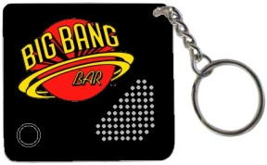
KEY – Audio Key Chain $10

This black key chain bears a red and yellow Planet Logo and plays ten seconds of Big Bang Bar audio with the press of a button. Batteries are included and replaceable (3x AG13). The picture to the right is a graphical mock-up. The actual item may look a little different.

This product is currently limited to 100 units. Additional runs will only be considered in 100 unit increments, based upon demand and therefore seems unlikely.

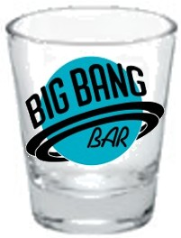
SHOT – 1.5 oz. Shot glass $3

A standard tapered shot glass with a custom two color Planet Logo. This shot glass was chosen for its similarity to the two shot glasses that are lying on their sides in front of the passed out green dragon/elephant on the cabinet. The picture to the right is a graphical mock-up. The actual item may look a little different.

This product is currently limited to 288 units. Additional runs will only be considered in 144 unit increments, based upon demand and therefore seems unlikely.

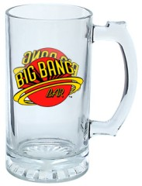
MUG – 16 oz. Beer mug $7

A glass mug with thumb-rest handle imprinted with a three color red and yellow Planet Logo on each side. This mug style was chosen for its similarity to the mug Ray is holding on the translite. The picture to the right is a graphical mock-up. The actual item may look a little different.

This product is currently limited to 144 units. Additional runs will only be considered in 144 unit increments, based upon demand and therefore seems unlikely.

BAT/BL – Blue Barrel, Purple Handle (only 17 units available)

BAT/GR – Light Green Barrel, Purple Handle (only 5 units available)

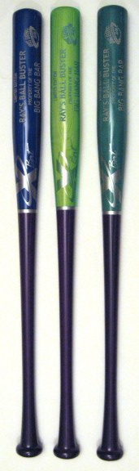
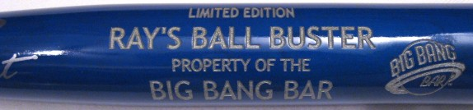
Ray’s Ball Buster - 33” engraved two-tone stained hardwood softball bat $80
The handles of the bats are stained dark purple in honor of the purple cabinet paint and the purple background of the cabinet art. The blue barrel color is reminiscent of the dark blue used in the cabinet art. The green barrel color is reminiscent of the light green used in the cabinet art. These bats were individually crafted so there are variations in the grain, coloring, and engraving.

This product is currently limited to 22 units. Please specify BAT/BL or BAT/GR and whether or not the other is acceptable if your first choice is sold out. Additional runs will only be considered in 12 unit increments, based upon demand.

The dark green barrel bat at the bottom of the picture was a production error that ended up being reminiscent of the dark green used in the cabinet art. The dark green bat may be made available if an additional run is done and the company can duplicate the color.

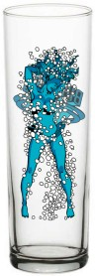
TUBE – Tube Dancer Glass $T/B/D (approx. $10±$2)

I hope to produce a hi-ball or zombie glass in the 13 oz. range that will have either the Tube Dancer on one side and a custom two-tone blue Planet Logo on the reverse or that has the Tube Dancer on both sides. There is a lot of detail in the Tube Dancer artwork and I have not found a suitable vendor that has both the glass that I want and the quality assurances that I desire. With luck I will find a vendor soon. I would love to know how much interest there is in this item so I can adjust the quantity ordered to match demand. The picture to the right is a graphical mock-up. The actual item may look somewhat different.

Additional Information
The prices shown are good through Monday, June 12, 2007. After this time prices may increase and the ability to purchase made-to-order items will be drastically reduced if not eliminated. Limited quantity items will be sold on a first come first served basis (based on the receipt of the order via email or regular mail). Items not paid for within 7 days will be made available to other buyers. All sales are final.

It is preferred that orders (using the BBB_Stuff_Order_Form.XLS) be emailed to BigBangBarStuff@gmail.com, so they can be reviewed and any additional shipping costs determined. You will receive an email confirming the availability of your desired items and the total amount due. Payment must be received within 7 days of that email.

Orders shipped to an Illinois address must include sales tax.

All orders must be paid for in U.S. dollars in the form of a Money Order or Cashier’s Check made payable to “Big Bang Bar Stuff”. Payments should be mailed to:

Big Bang Bar Stuff
318 Half Day Rd #246
Buffalo Grove, IL 60089

We will assume no responsibility for lost, stolen, or damaged shipments. Shipping insurance, if desired, is the responsibility of the buyer and is especially recommended for glassware despite the care with which we will package orders. We will assist buyers to the best of our abilities with any insurance claims that may arise.

Apparel** Standard
Total: Shipping Cost:
$0 - $25 $6.00
$26 - $50 $8.00
$51 - $75 $11.00
$76 - $100 $14.00
$101 - $200 $17.00
$201 - $300 $21.00
$301 - $400 $25.00
$401 - $600 $30.00
over $600 T/B/D

** The above table is for the shipment of apparel, towels, and key chains. Additional shipping charges may apply to orders that include glassware and/or bats which may need to be shipped separately due to their size, weight, and/or fragile nature. Shipping on international orders will be determined on an individual basis. All taxes, duties, fees, etc. not included in the shipping charges are the responsibility of the buyer.

The apparel and other embroidered items will be produced once the orders have been received so that people can pick the sizes, colors, and art packages that they prefer. Remember to add $6 if you want art on the shirt back. We expect final production to take 2-4 weeks starting June 13, 2007. Your order will be shipped when it is complete.

